**THE UNIVERSITY OF ZAMBIA**

**IN CONJUCTION WITH**

**ZAMBIA ICT COLLEGE**

**STUDENT NAME: Dumisani Lesley Zulu**

**STUDENT ID: 1810923**

**PROGRAM: BACHELOR OF INFORMATION AND COMMUNICATION TECHNOLOGY**

**COURSE: Object Oriented System Analysis and Design**

**COURSE CODE:**

**LECTURER: Mr. Nkole**

**ASSIGNMENT: Covid 19 assignment**

**QUESTION ONE**

Class Diagram Elements

generalization • composition • object return type • aggregation • public operation • private attribute • multiplicity • class name • visibility modifier • primitive attribute • protected operation • dependency

**QUESTION TWO**

**UML Use Case**

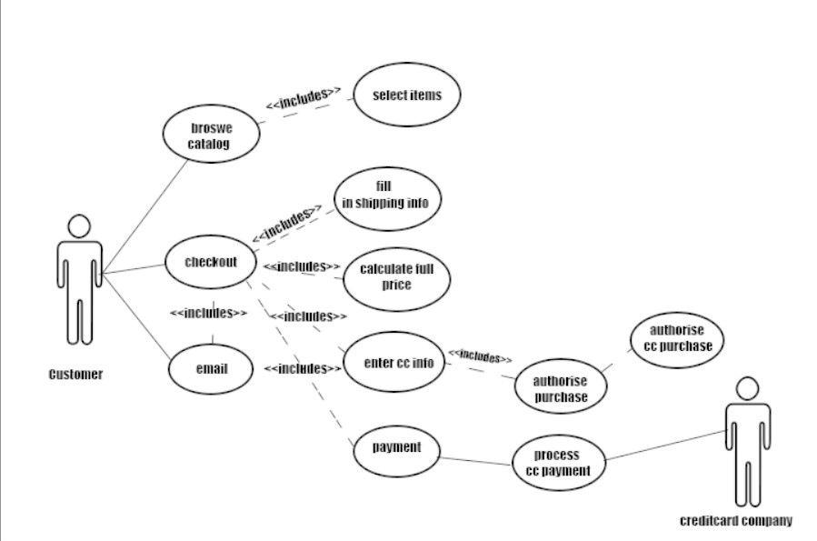

**QUESTION THREE**

Is the development mainly experimental, or will it become a commercial/open-source product with users other than the developers themselves? If the project is experimental, or a “spike,” then no formal process is needed at all. If not, then more thought is required.

Risk factors. Could someone get hurt or die if the software doesn’t work correctly? If so, then agile methods may not be as appropriate as a more regimented waterfall-like process. This is not to say that agile methods cannot be used at all, but more care would need to be taken if, for example, Scrum was the chosen process.

Deployment method. One extreme being Software-as-a-Service (SaaS) and the other is a scenario where a skilled install technician brings the software (and possibly the hardware) to the install site, and performs the installation there. Commercial off-theshelf (COTS) is somewhere between these extremes. Agile methods like XP and Scrum are often the best choice for SaaS because they tend to allow the development team to do more frequent releases.

Do the developers and the stakeholders understand the problem, and potential solution, well? If not, then a process that lets the stakeholders participate in early UAT might be best. Strict Waterfall (or Spiral for first release) may be a bad choice in this case because UAT only happens at the end, when correcting design mistakes is much more expensive.